ULTRASONIC TESTING REPORT
Company/Client: NCOC N.V. |  |  | Project: ESKENE WEST KARABATAN |  |  |  |  | Location: PGP
Drawing/Tag No:  A1-690-XX-003 |  |  | Component examined | Material |  | P295GH |  | Probe sensitivity calibration
Procedure No:  GOST 28702-90  QP-11-UTT-Q01 Rev 01 |  |  | Component examined | Día X Nominal Thickness |  | Dia. 2200 mm  According to table |  | Probe S/N |  | D7906  925366
 |  |  | Component examined | Operating Temp |  | 30º C |  | Angle |  | 0º
Manufacturing Code:  ASME B31.3*  ASME Sec VIII D.1  Acceptance Standard: Client spec. |  |  | Reference Calibration Block Details | Block |  | Step wedge |  | Frequency |  | 5 MHz
 |  |  | Reference Calibration Block Details | Range |  | CS (6.25-25 mm) |  | size |  | 11 mm
Method: Contact |  |  | Reference Calibration Block Details | Accuracy |  | 0.025 mm |  | Crystal |  | Dual
Surface condition: uncoated |  |  | Reference Calibration Block Details | Temperature |  | Ambient |  | Reference sensitivity |  | 2nd backwall reflection to 80% FSH
Couplant: UT Gel |  |  | Correction factors |  |  | N/A |  | Scan Sensitivity |  | Reference dB
S. No | Equipment/  Material Name | Manufacturer |  |  | Serial No |  | Calibration certificate No |  | Calibration Expiry date
 | A-scan UT | OLYMPUS DL-38 |  |  | 171421601 |  | 2113237 |  | 02-04-2019
 | Step wedge calibration block | OLYMPUS |  |  | 145414 |  | - |  | -
Job description:

- UT spot thickness measurement was performed on shell and tube sheets the heating generator A1-690-XX-003.
- UT spot check was performed on North, South, East, West, Top and Bottom side related to object position.

Note:*no information in boiler passport and tag plate. ASME VIII div.1 and ASME B31.3 were taken as the standard for this boiler.
N/A – not applicable.
FSH: Full Screen Height

Drawings & Inspection photos
A1-690-XX-003
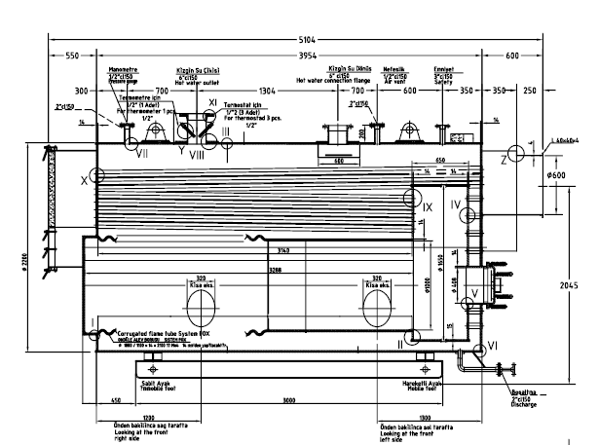
View B
View A
View C
I
II
III
VII
General view
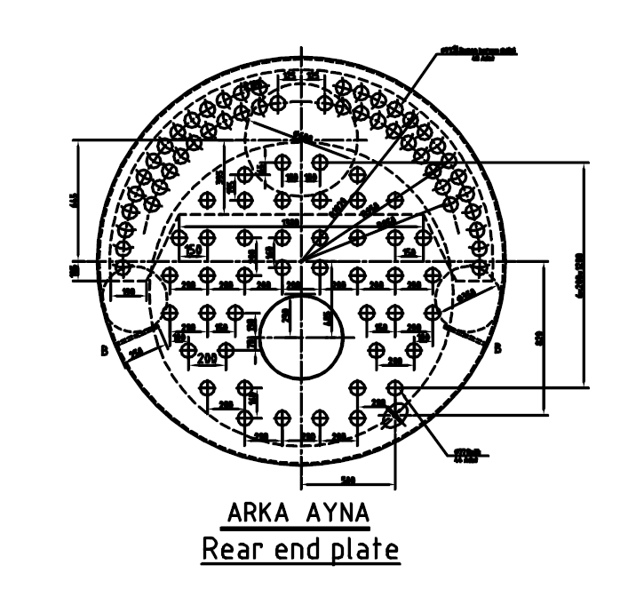  View C  East  Top  Bottom  West  East  1  2  3  4  5  IV |  |  |  |  |  |  |  |  | 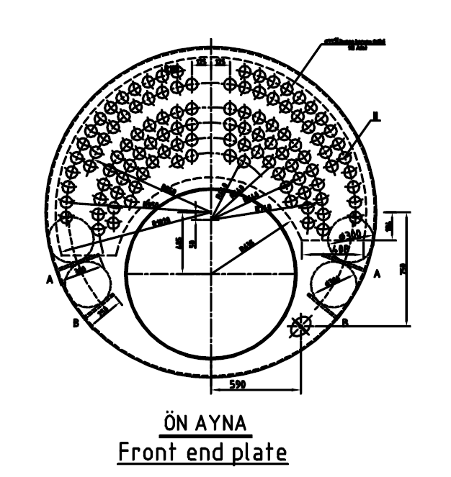  View B  Top  West  Bottom  1  23  3  4  V
View A
East
Top
West
Bottom
VI
1
4
2
3
DETAILS AND RESULTS
S/N | Item description | Dia.  (mm) |  |  |  | Nominal WT  (mm) | Location |  |  |  | Top  (mm) |  | Bottom  (mm) |  |  | West  (mm) |  | East  (mm)
1 | Shell (main tube) | 1000 |  |  |  | 14 | I |  |  |  | 14.30 |  | 14.30 |  |  | 14.60 |  | 13.09
2 | Shell (main tube) | 1000 |  |  |  | 14 | II |  |  |  | 14.50 |  | 15.00 |  |  | 15.00 |  | 14.64
3 | Shell (main tube) | 1650 |  |  |  | 15 | III |  |  |  | 15.88 |  | 16.15 |  |  | 16.01 |  | 15.75
S/N | Item description | Dia.  (Inch) |  |  |  | Nominal WT  (mm) | Location |  |  |  | North  (mm) |  | South  (mm) |  |  | West  (mm) |  | East  (mm)
1 | Nozzle | 2 |  |  |  | No info | VII |  |  |  | 6.82 |  | 6.90 |  |  | 8.20 |  | 7.90
S/N | Item description |  | Dia.  (mm) |  | Nominal WT  (mm) |  |  | Location |  | 1  (mm) |  | 2  (mm) |  | 3  (mm) |  |  | 4  (mm) |  | 5  (mm)
1 | Tube sheet |  | 1000 |  | 14 |  |  | IV |  | 14.58 |  | 14.73 |  | 14.57 |  |  | 14.81 |  | 14.70
2 | Tube sheet |  | 2040 |  | 14 |  |  | V |  | 14.40 |  | 14.16 |  | 14.22 |  |  | 14.24 |  | -
3 | Tube sheet |  | 2040 |  | 14 |  |  | VI |  | 14.52 |  | 14.38 |  | 14.22 |  |  | 14.31 |  | -
Examined by  UT L II cert. No 356  exp. date: 28.04.2021 |  |  |  | Name: Dosbatyrov Damir |  |  |  |  | Signature: ............................ |  |  |  |  |  | Date: 18.07.2018
Approved by  UT L III cert. No 1A123/15  expiry date 29.02.2020 |  |  |  | Name: Shundryk Ihar |  |  |  |  | Signature: ............................ |  |  |  |  |  | Date: 18.07.2018
Client Representative: |  |  |  | Name:..………………………… |  |  |  |  | Signature: ............................ |  |  |  |  |  | Date…………...…

